Project Management Setup:

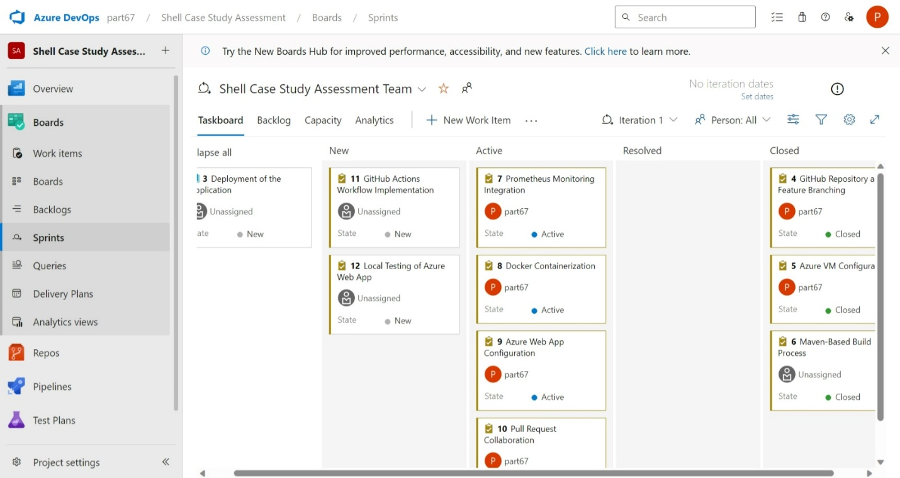

Azure VM Configuration:

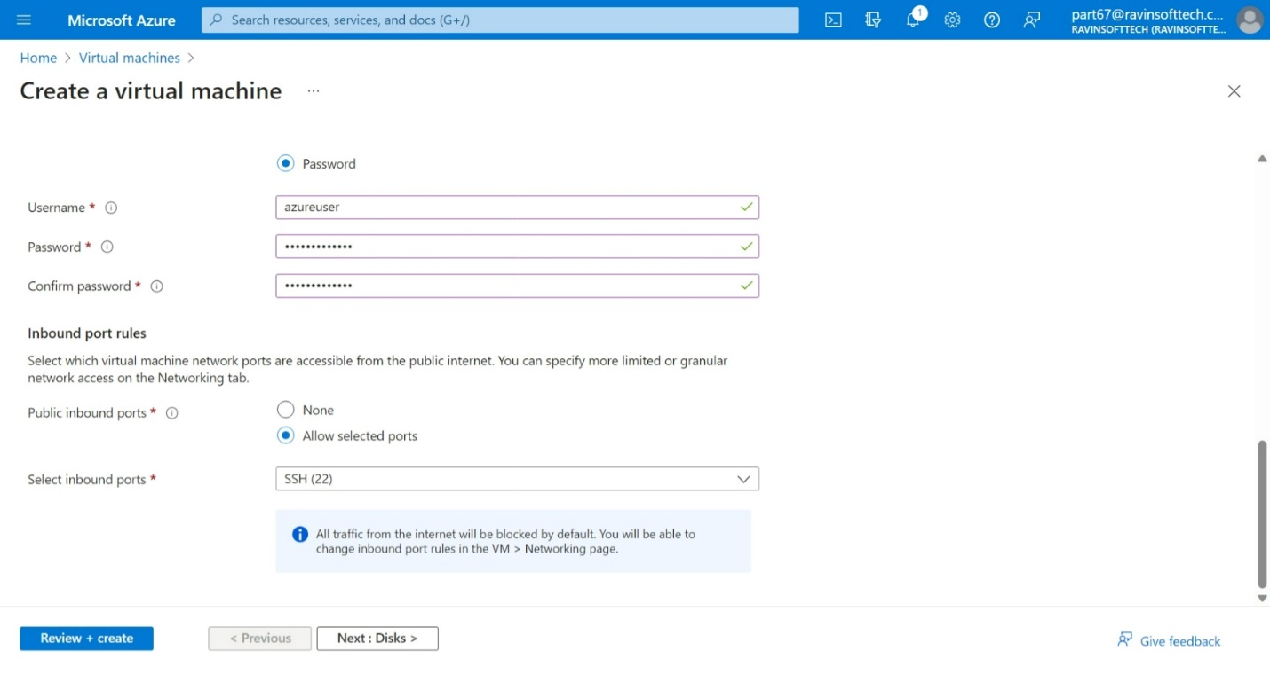

Github Repository and Feature Branching:

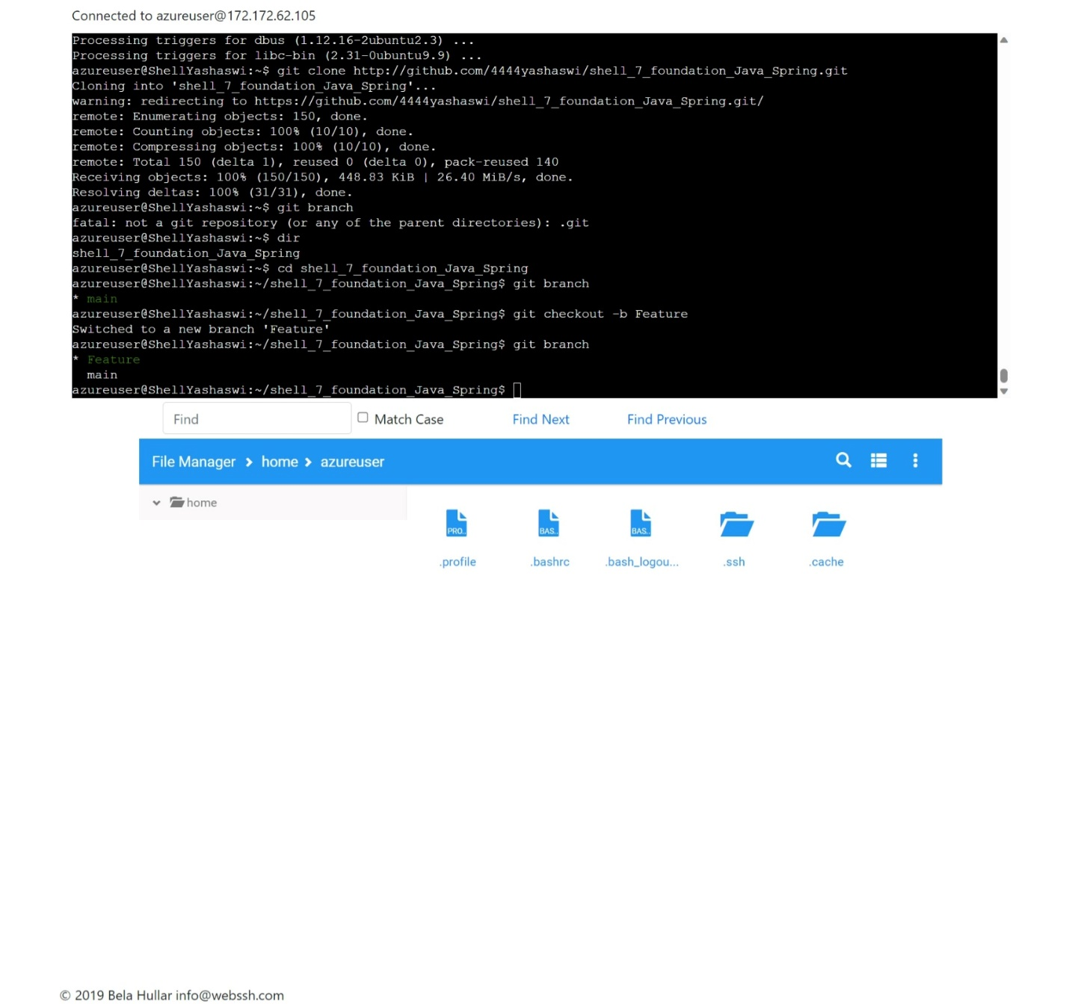

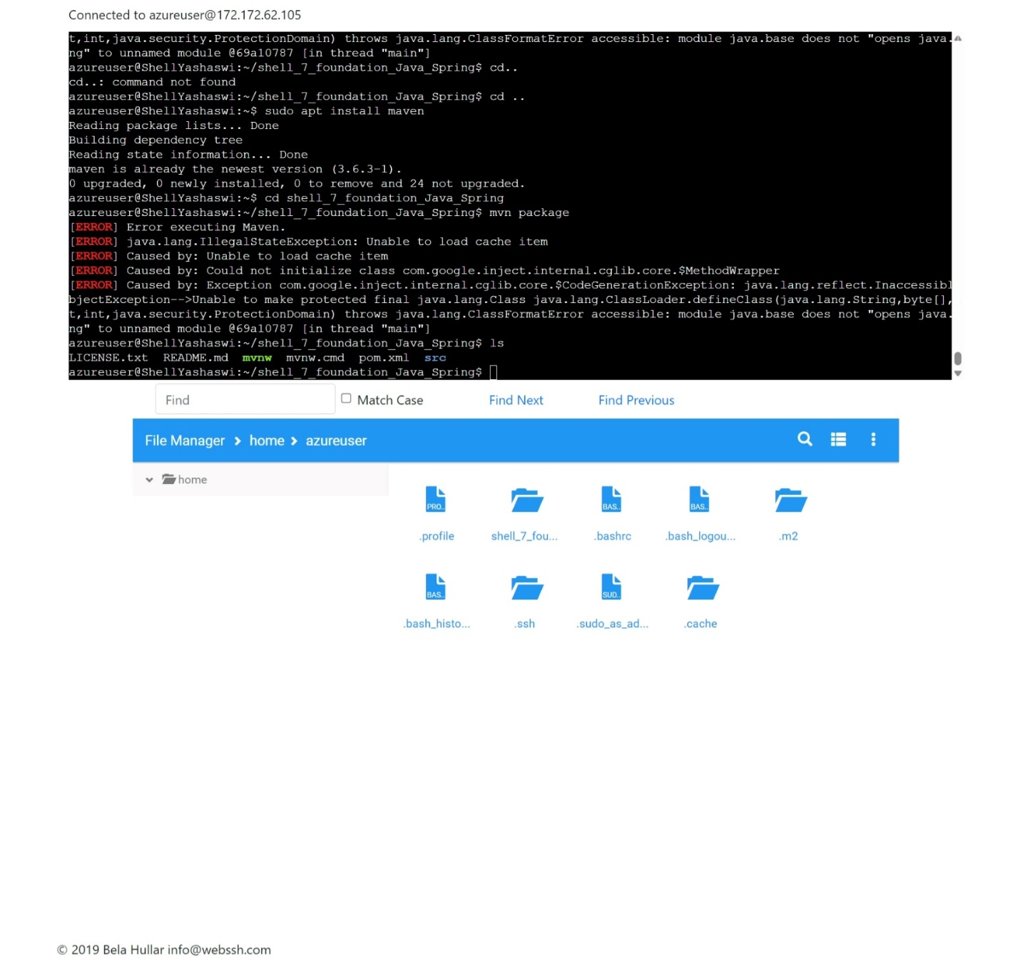

Azure Web App Configuration:

GitHub Actions Workflow Implementation: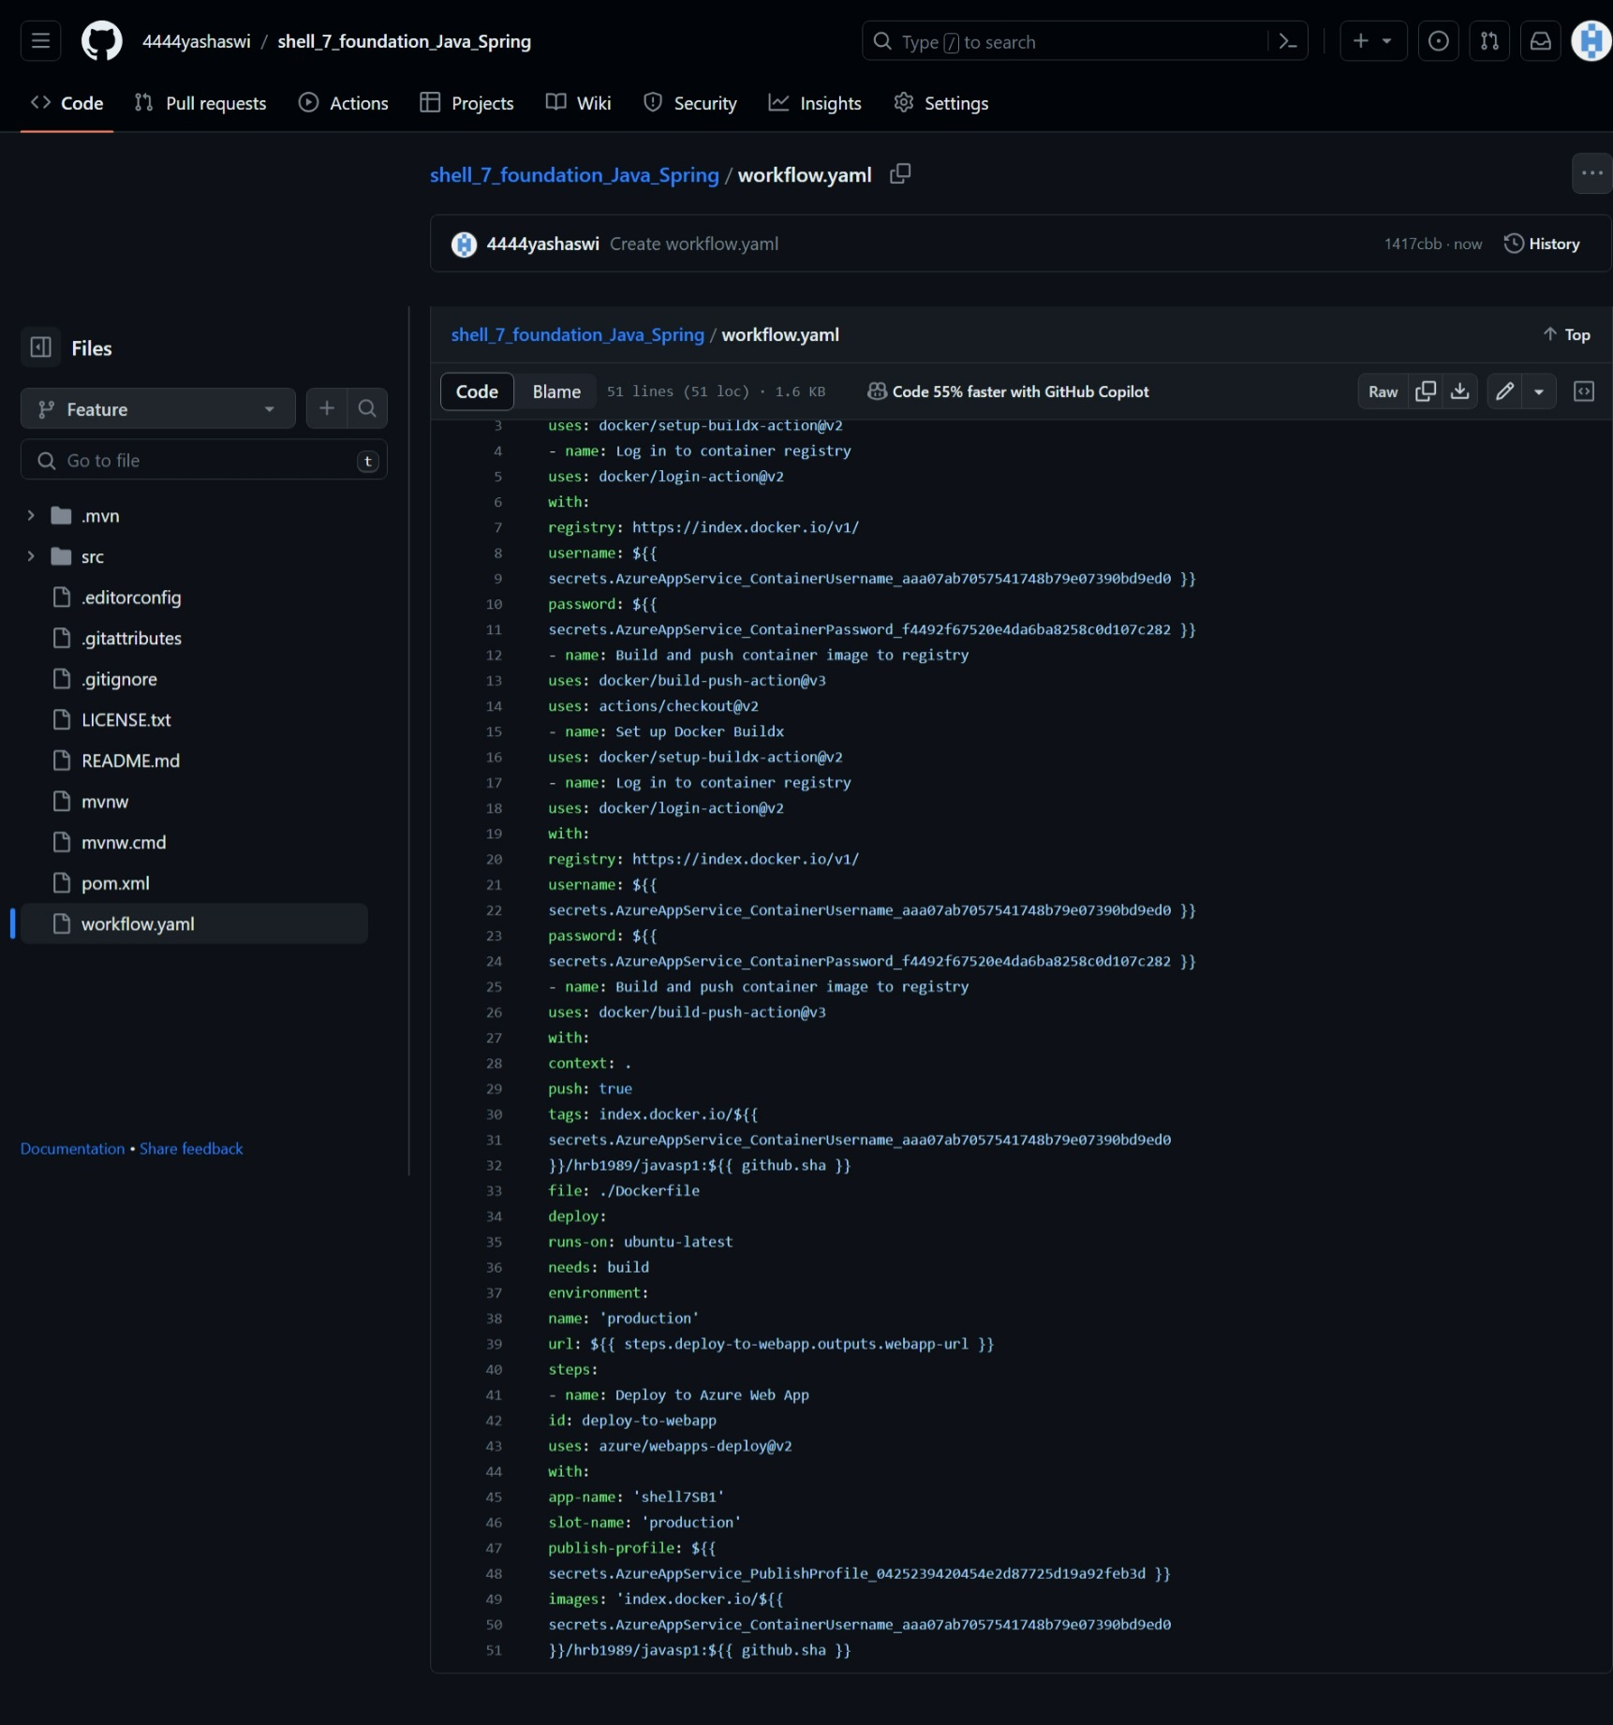

Test case:

